**Spiceworks – Main page**

Scrap the same data for all products (Here it is 138 products in networking category in the image below)

Links for different product categories:

* [Networking](https://community.spiceworks.com/networking/product/reviews?selector_query=dell)
* [Storage](http://community.spiceworks.com/storage/product/reviews?utf8=%E2%9C%93&source=channel_search_bar&selector_query=dell)
* [Servers](•%09http:/community.spiceworks.com/hardware/server-storage/reviews?selector_query=dell)

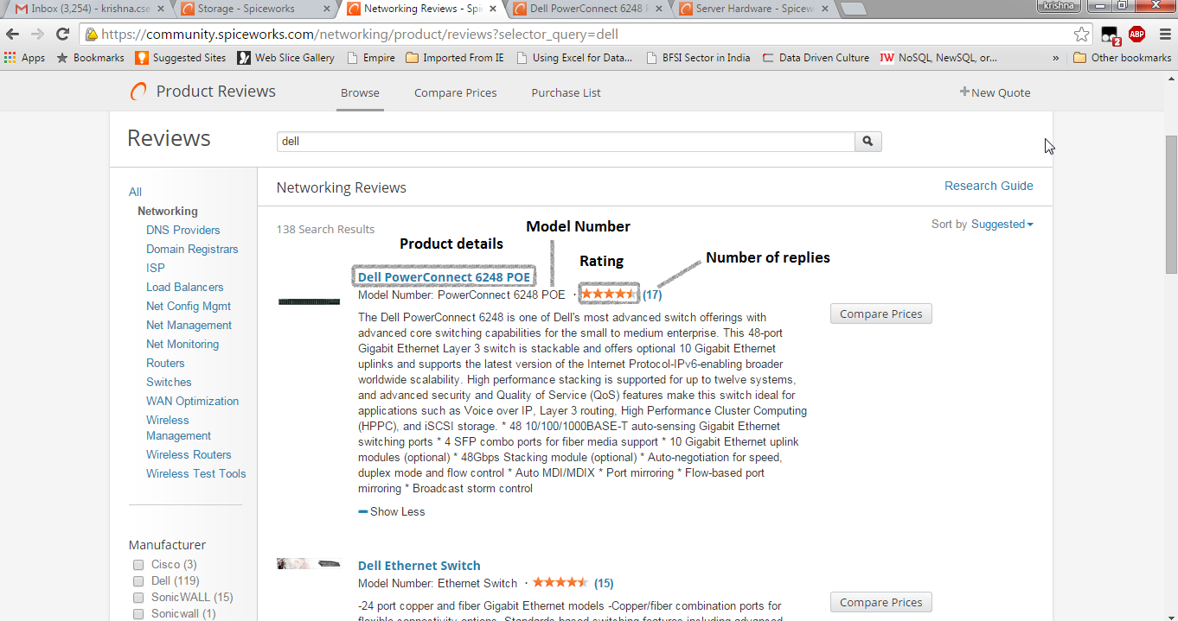

We require Product Title, Model Number and rating from the main page.

When you click on any of the products, you enter into product page where you need to scrap the data as per below.

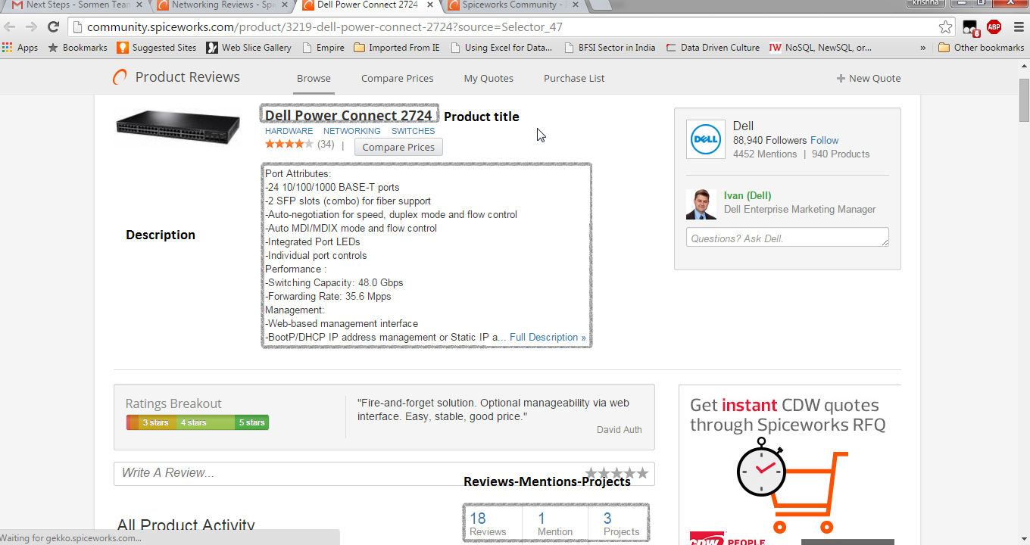

From this capture the description of the product, the number of reviews (18 in the above image) of the products.

By default, the reviews, mentions and projects are mixed, you need to click on the reviews and mentions to capture specific details regarding them as below

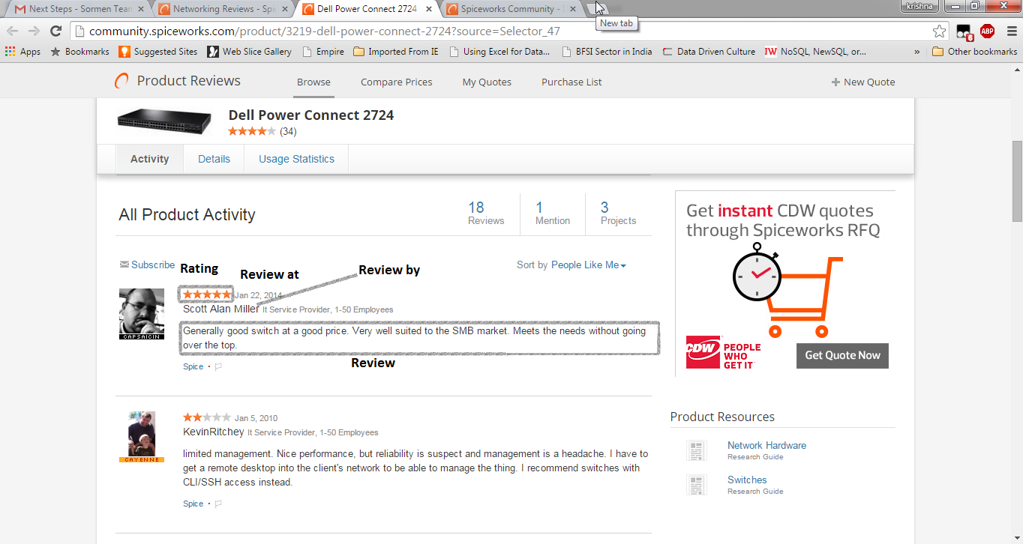

Capture the review by, review at, review-rating and review after clicking on reviews.

Refer to the Main page in new template for table structure.